EXPT NO: 7 | GENERATE SYNTHETIC IMAGES USING A GENERATIVE ADVERSARIAL NETWORK (GAN)
DATE: 5/10/26

PRE-LAB QUESTIONS (PROVIDE BRIEF ANSWERS TO THE FOLLOWING QUESTIONS)

1. What is a Generative Adversarial Network (GAN)?
A Generative Adversarial Network (GAN) is a deep learning model used to generate new data that resembles real data. It consists of two neural networks: a Generator and a Discriminator. The Generator creates synthetic data, while the Discriminator evaluates whether the data is real or generated. Both networks are trained simultaneously in competition with each other. GANs are commonly used for image generation, image enhancement, data augmentation, and creating realistic synthetic images.

2. What are the roles of the Generator and Discriminator in a GAN?
A GAN consists of two main components:
- Generator: Creates synthetic images from random noise. Its goal is to generate images that are realistic enough to fool the Discriminator.
- Discriminator: Classifies input images as either real or synthetic. Its goal is to correctly distinguish generated images from real images.
The Generator improves its image generation based on the Discriminator's feedback, while the Discriminator becomes better at detecting fake images.

3. Why are GANs used for synthetic image generation?
GANs are used for synthetic image generation because they can learn the underlying patterns and features of real images and generate new, realistic-looking images. They are useful when large amounts of real training data are unavailable or difficult to collect. GANs can generate diverse images while preserving important visual characteristics. Applications include face generation, medical imaging, image-to-image translation, super-resolution, data augmentation, and realistic scene generation.

4. Difference between Real Images and Synthetic Images
Feature | Real Images | Synthetic Images
Source | Captured from the real world | Generated using computational models
Creation | Camera or imaging device | AI/model-based generation
Authenticity | Represents actual objects/scenes | Artificially created
Variability | Naturally occurring | Controlled by the generation process
Examples | Photograph of a person | GAN-generated person's face

5. Explain the concept of adversarial training in GANs.
Adversarial training is the process where the Generator and Discriminator compete against each other during GAN training. The Generator tries to create realistic synthetic images that can fool the Discriminator. The Discriminator tries to correctly identify whether an image is real or generated. This competition continuously improves both networks. Eventually, the Generator learns to produce highly realistic images that are difficult for the Discriminator to distinguish from real images.

AIM
To implement a Generative Adversarial Network (GAN) for generating synthetic images by training a Generator and Discriminator on an image dataset and evaluating the quality of the generated images.

SOFTWARE REQUIREMENTS
- Python
- TensorFlow / Keras
- Google Colab
- GitHub
- NumPy
- Matplotlib
- Pandas

OBJECTIVES
Students will be able to:
- Understand the architecture and working of Generative Adversarial Networks.
- Understand the roles of the Generator and Discriminator.
- Prepare and preprocess an image dataset for GAN training.
- Build a Generator network for synthetic image generation.
- Build a Discriminator network for distinguishing real and generated images.
- Train a GAN using adversarial learning.
- Generate synthetic images using the trained Generator.
- Visualize and analyze the quality of generated images.

PROCEDURE
PART A: DATASET PREPARATION AND IMAGE PREPROCESSING
Perform the following tasks:
- Load an image dataset such as the MNIST handwritten digit dataset.
- Explore the dataset and examine sample images.
- Check the number of images and image dimensions.
- Display sample images from the dataset.
- Normalize the pixel values to the range [-1, 1].
- Reshape the images into the required input format.
- Prepare the dataset for batch-wise training.
- Create a data pipeline using appropriate TensorFlow/Keras utilities.

PART B: IMPLEMENTING THE GENERATOR
Perform the following tasks:
- Define a random noise vector as the input to the Generator.
- Create the Generator using appropriate neural network layers.
- Use Dense and convolutional/transposed convolutional layers to generate images.
- Apply appropriate activation functions.
- Generate an image from a random noise vector.
- Display the generated image before GAN training.
- Display the Generator model architecture and summary.

PART C: IMPLEMENTING THE DISCRIMINATOR AND GAN MODEL
Perform the following tasks:
- Create a Discriminator network to classify images as real or generated.
- Add convolutional layers to extract image features.
- Add appropriate activation functions.
- Add a final output layer for binary classification.
- Compile the Discriminator using:
  - Appropriate optimizer
  - Binary cross-entropy loss
- Combine the Generator and Discriminator to form the GAN.
- Display the Generator and Discriminator model summaries.

PART D: GAN TRAINING AND SYNTHETIC IMAGE GENERATION
Perform the following tasks:
- Initialize the Generator with random noise.
- Train the Discriminator using:
  - Real images from the dataset.
  - Synthetic images generated by the Generator.
- Train the Generator through the combined GAN model.
- Record:
  - Generator loss
  - Discriminator loss
- Repeat the training process for the specified number of epochs.
- Generate synthetic images at regular training intervals.
- Visualize generated images at different stages of training.
- Compare the generated images with real images.
- Analyze the quality and diversity of the generated images.
- Save the final generated images.

EXPECTED OUTCOME
Students will understand the architecture and working of Generative Adversarial Networks (GANs) and the interaction between the Generator and Discriminator during adversarial training. Students will learn to preprocess image data, build and train GAN models, and generate synthetic images. They will evaluate the generated images by visually comparing them with real images and analyzing the improvement in image quality during training.

POST-LAB QUESTIONS (PROVIDE BRIEF ANSWERS TO THE FOLLOWING QUESTIONS)

1. What is the role of the Generator in a GAN?
The Generator is a neural network that creates synthetic data, such as images, from random noise. Its main objective is to produce realistic data that resembles the real training data. During training, the Generator receives feedback from the Discriminator and learns to improve its outputs. Over time, it becomes better at generating realistic images that are difficult for the Discriminator to distinguish from real images.

2. What is the role of the Discriminator in a GAN?
The Discriminator is a neural network that distinguishes between real data from the training dataset and synthetic data produced by the Generator. It outputs a probability indicating whether an input is real or fake. Its objective is to correctly classify both types of data. The feedback provided by the Discriminator helps the Generator improve the realism and quality of its generated images.

3. Why is random noise used as input to the Generator?
Random noise provides the Generator with a starting point from which it can create different synthetic samples. By using different random noise vectors, the Generator can produce diverse images rather than repeatedly generating the same image. The noise is transformed through the Generator's neural network into meaningful features and eventually into a complete image. Thus, random noise helps GANs generate varied and realistic outputs.

4. What happens when the Discriminator becomes too strong during GAN training?
If the Discriminator becomes too strong, it can easily distinguish real images from generated images. As a result, the Generator receives very weak or uninformative gradients and struggles to improve. This can make GAN training unstable and slow down Generator learning. The generated images may remain poor in quality. Therefore, maintaining a reasonable balance between the Generator and Discriminator is important for stable and effective GAN training.

5. What is meant by mode collapse in GANs?
Mode collapse is a common problem in GAN training where the Generator produces very similar or identical outputs instead of generating diverse samples. The Generator discovers a limited type of output that successfully fools the Discriminator and repeatedly generates it. Although these images may look realistic, they lack diversity and fail to represent the different patterns present in the training dataset.

6. How does the Generator improve the quality of generated images during training?
The Generator improves through feedback from the Discriminator. Initially, it produces poor-quality images. The Discriminator identifies them as fake and provides a learning signal through its loss. The Generator uses backpropagation and gradient-based optimization to update its weights. Through repeated training iterations, it learns important patterns, features, textures, and structures from real data, gradually producing more realistic and higher-quality images.

7. Mention one real-world application of GANs.
One important real-world application of GANs is image generation. GANs can generate realistic human faces that do not belong to real people. They are also used in medical image synthesis, image super-resolution, data augmentation, image-to-image translation, fashion design, and game development. For example, GAN-generated images can increase the amount of training data available for machine learning models when collecting real images is expensive or difficult.

8. Difference between GAN Training and Conventional Neural Network Training
Feature | GAN Training | Conventional Neural Network Training
Networks | Two networks: Generator and Discriminator | Usually one main network
Objective | Networks compete with each other | Minimize prediction error
Training | Adversarial | Direct optimization
Feedback | Discriminator guides Generator | Loss function guides model
Main Goal | Generate realistic data | Make accurate predictions

SUGGESTIONS FOR DATASETS
- MNIST Handwritten Digits – https://www.tensorflow.org/datasets/catalog/mnist
- Fashion-MNIST – https://www.tensorflow.org/datasets/catalog/fashion_mnist
- CIFAR-10 – https://www.tensorflow.org/datasets/catalog/cifar10
- CelebA – https://www.tensorflow.org/datasets/catalog/celeb_a
- Oxford-IIIT Pet Dataset – https://www.tensorflow.org/datasets/catalog/oxford_iiit_pet
Screenshots
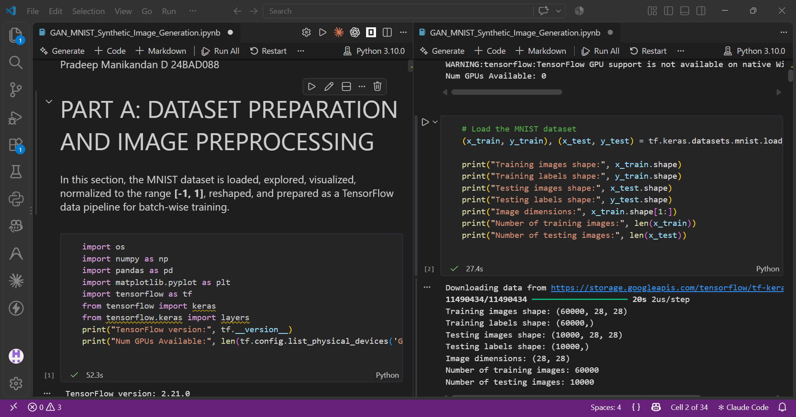

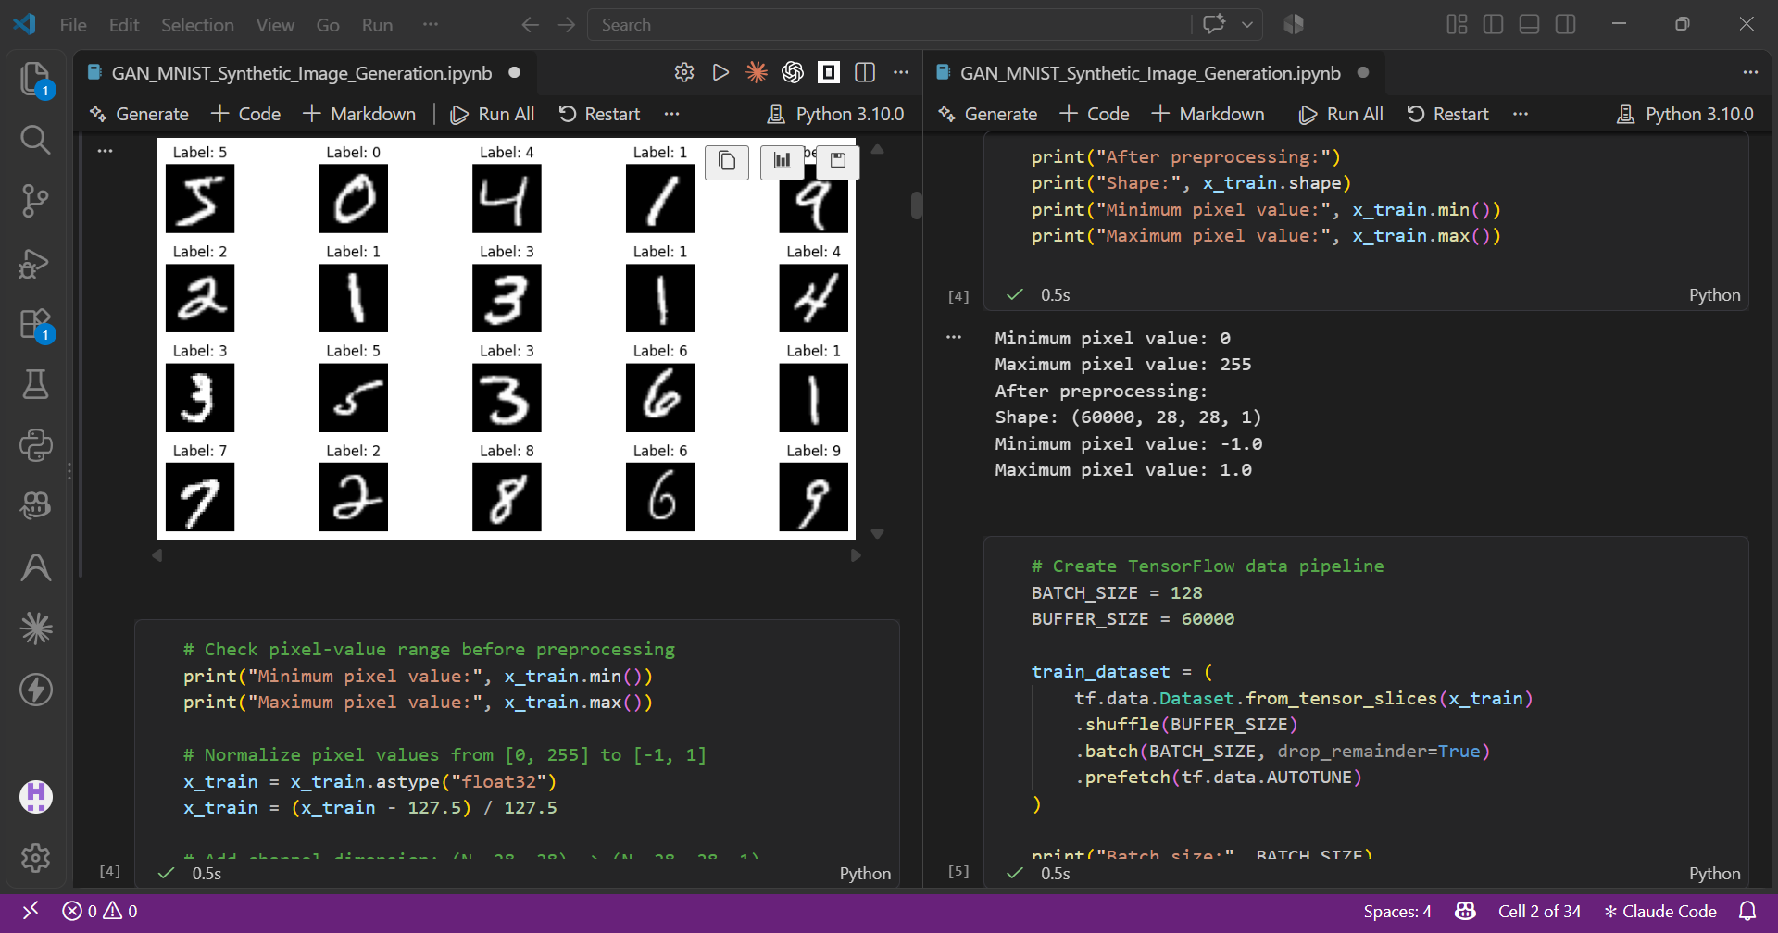

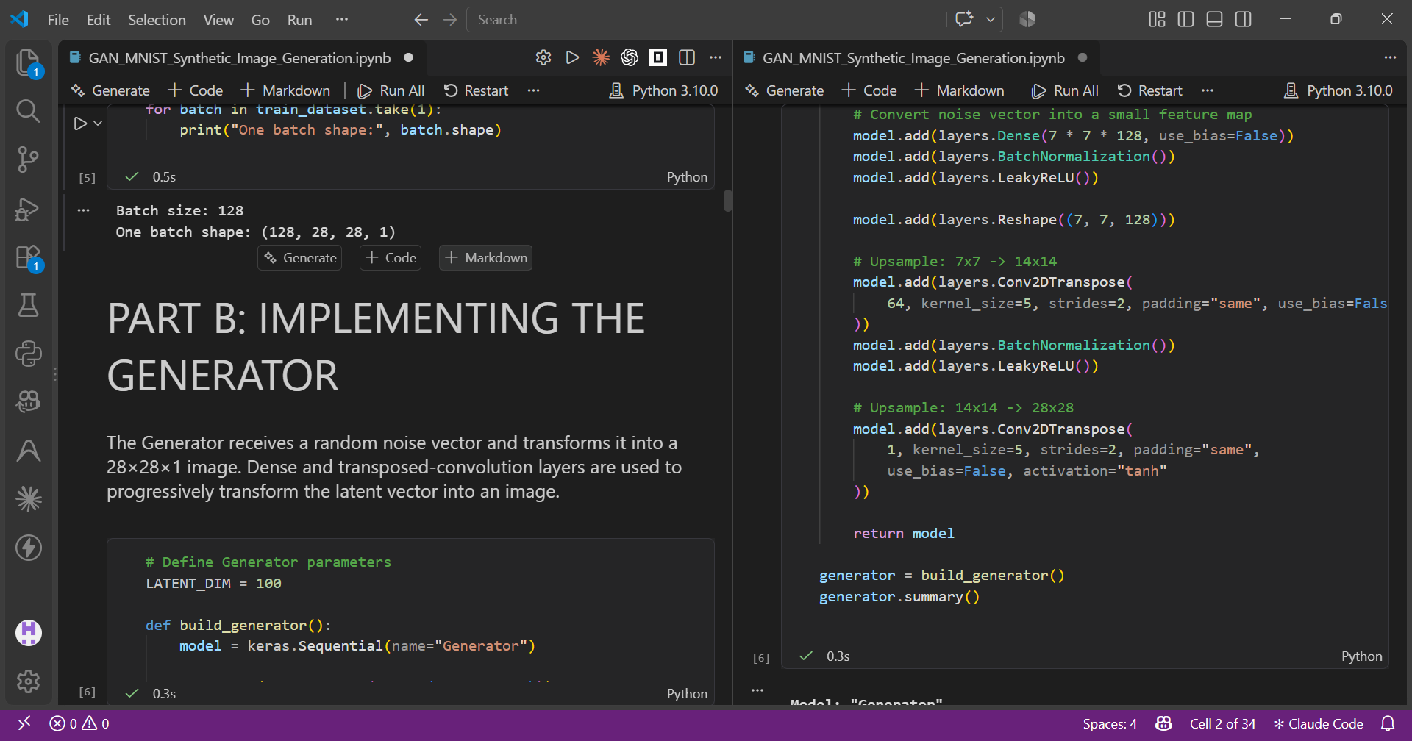

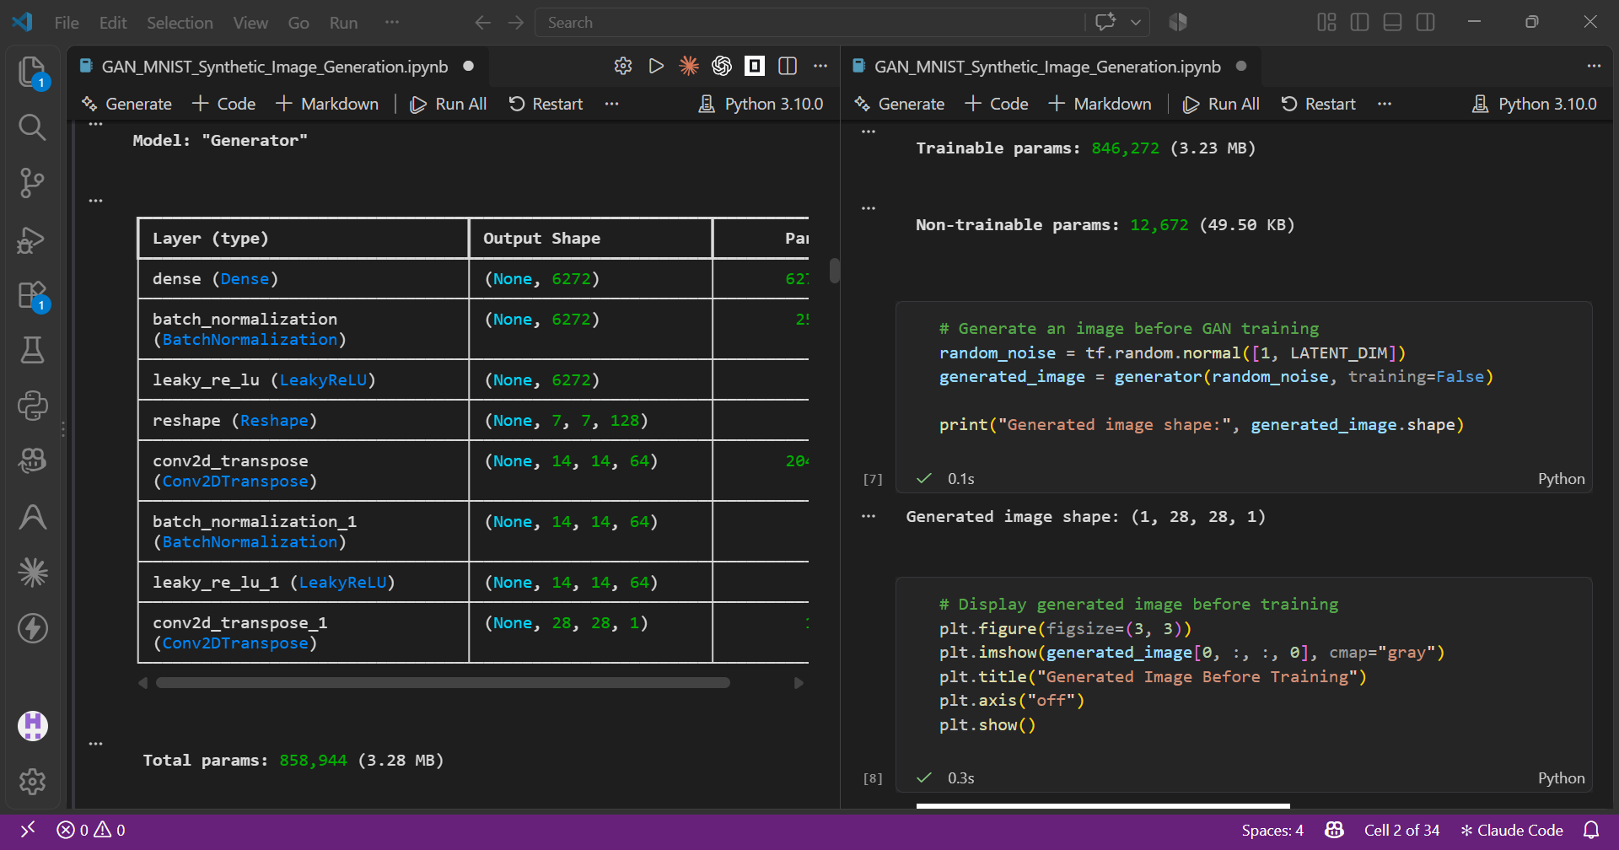
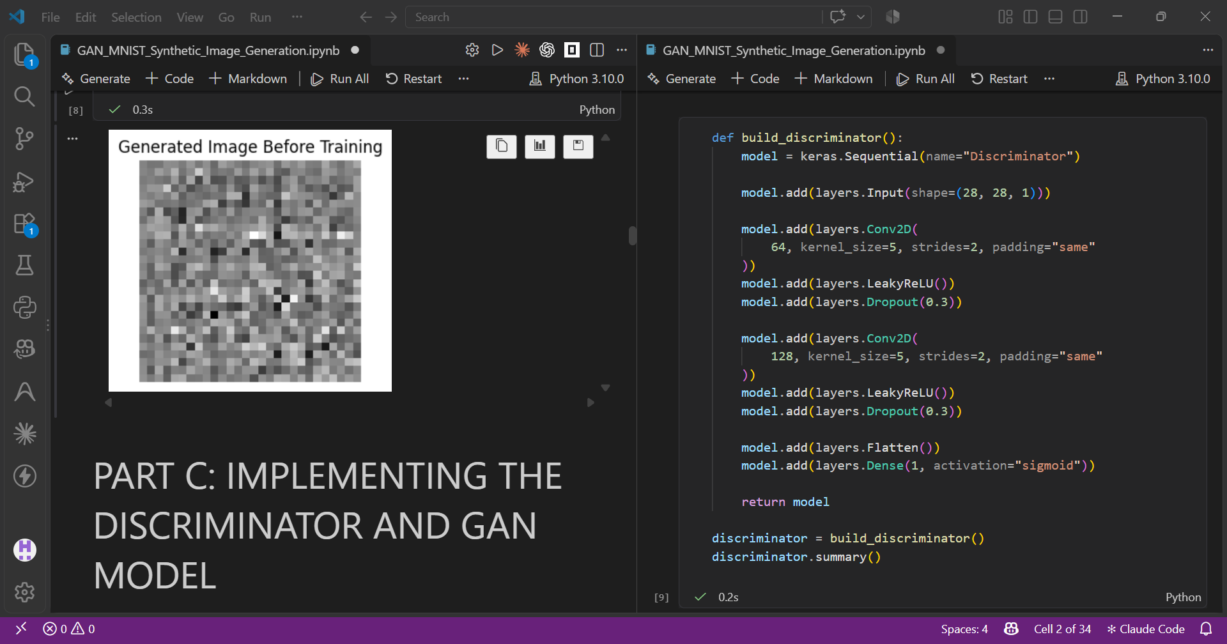

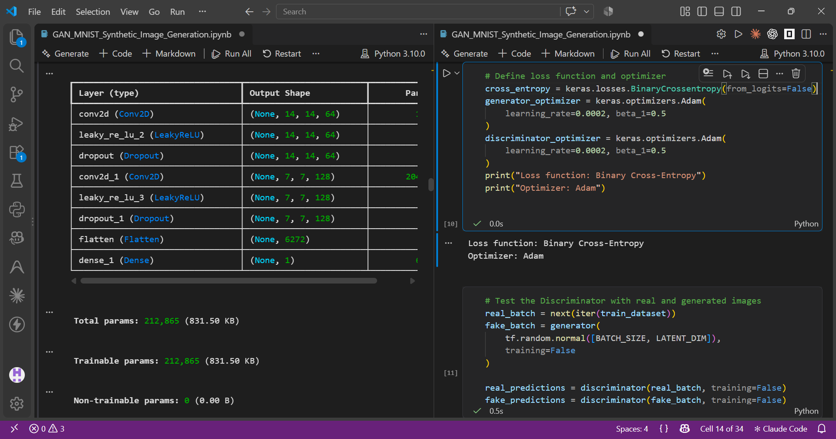
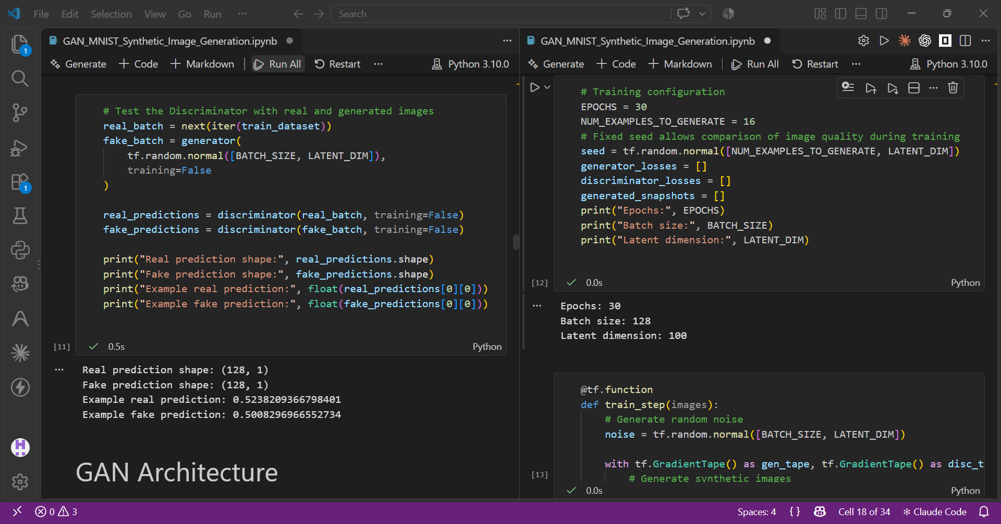
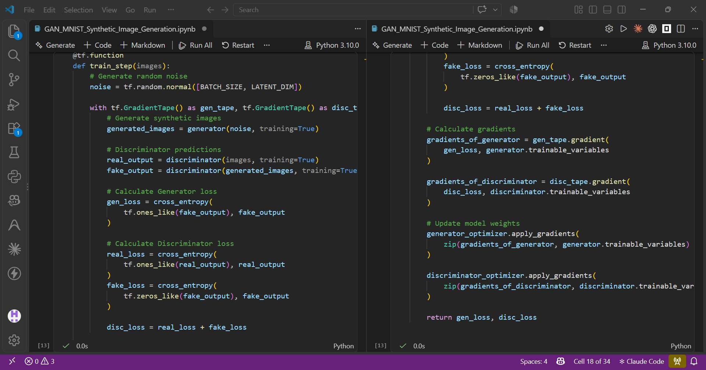
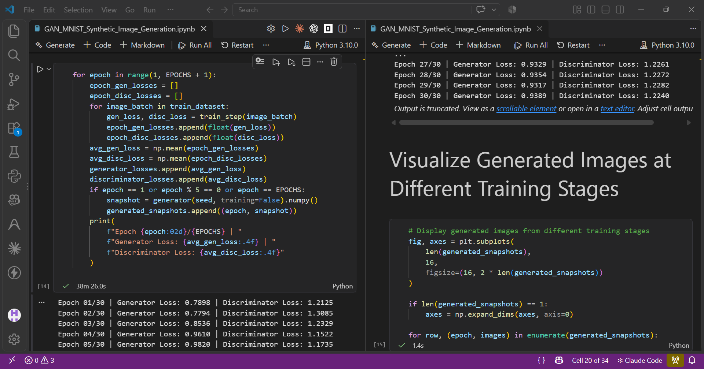
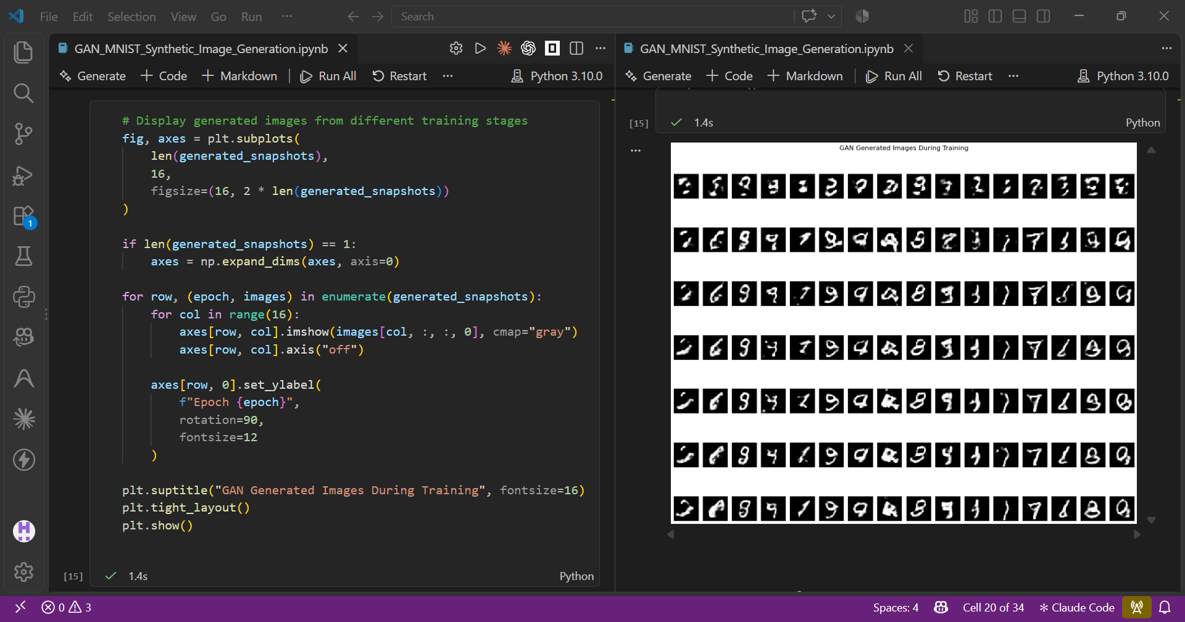

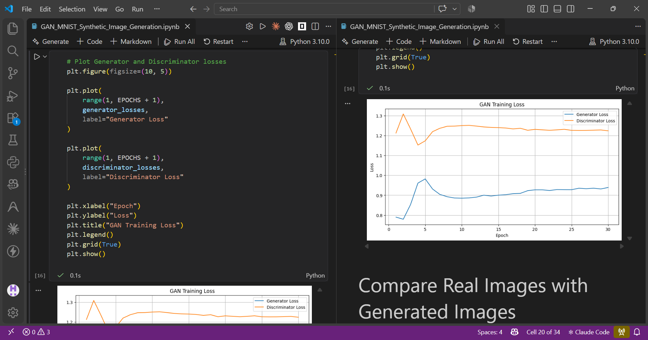
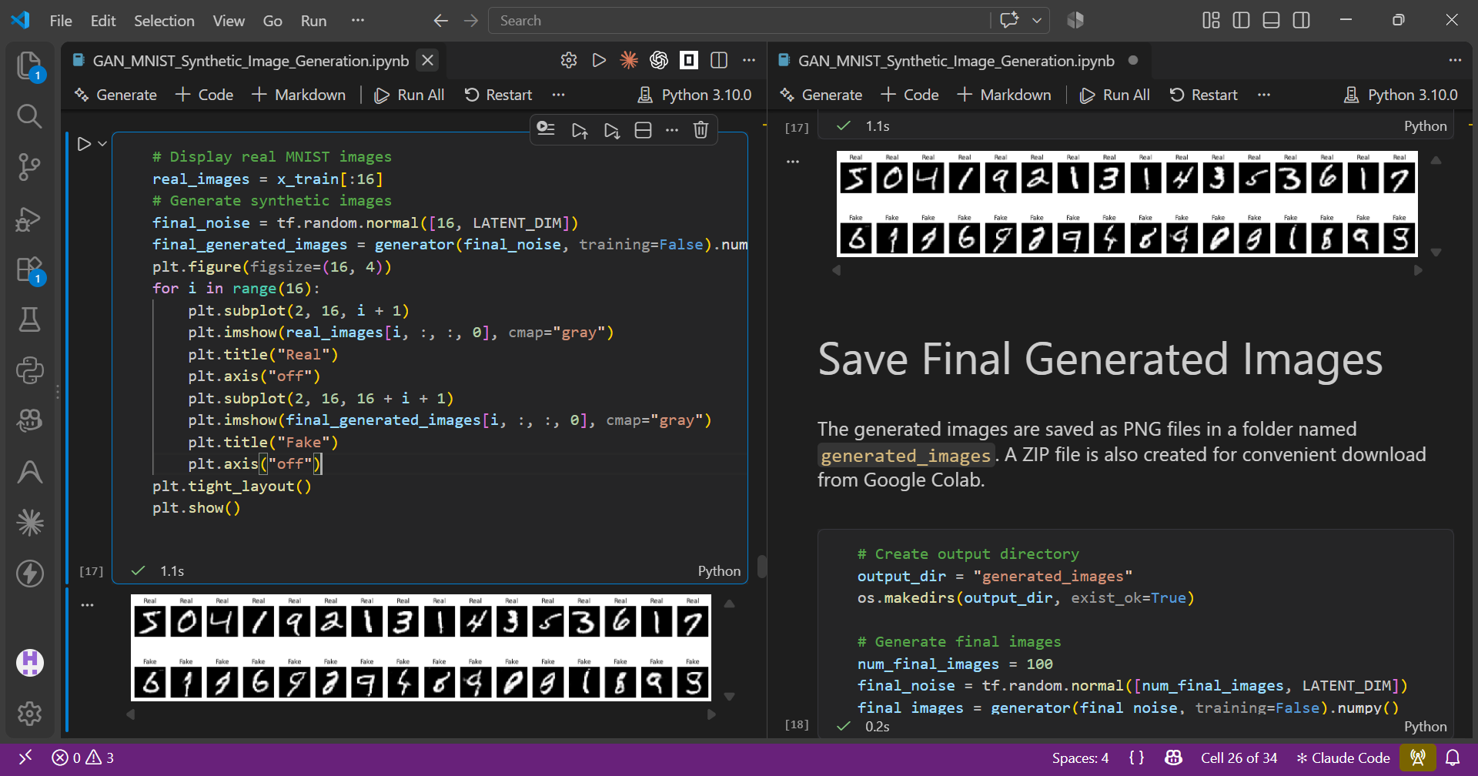
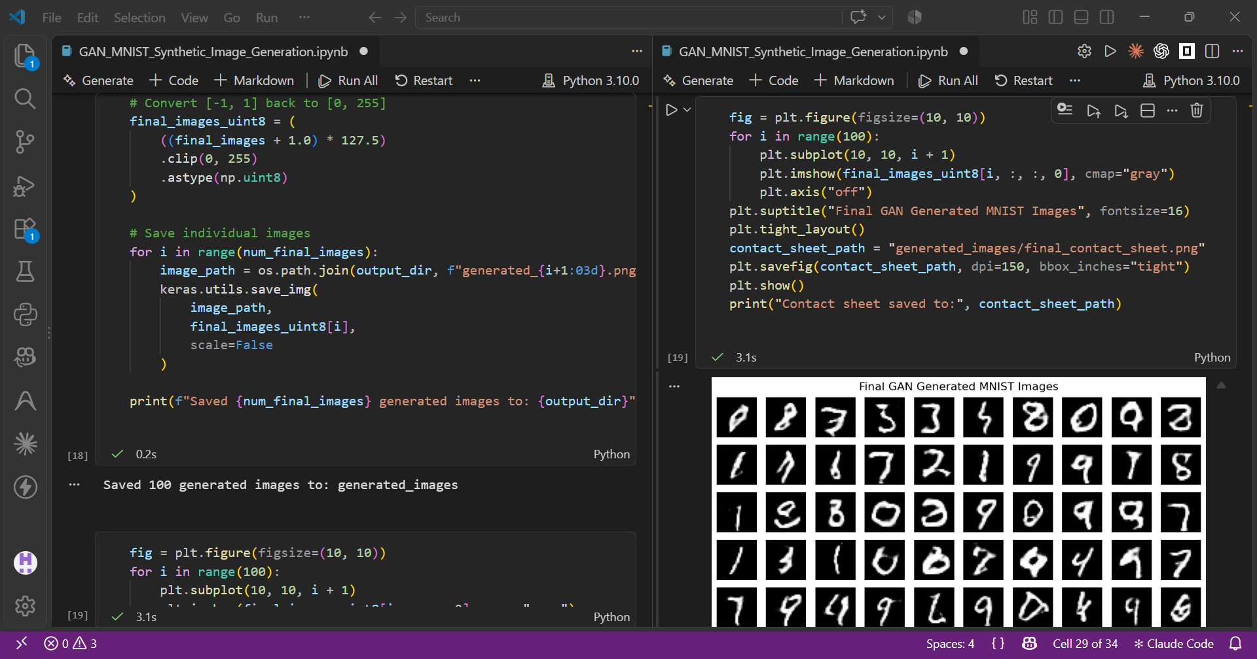
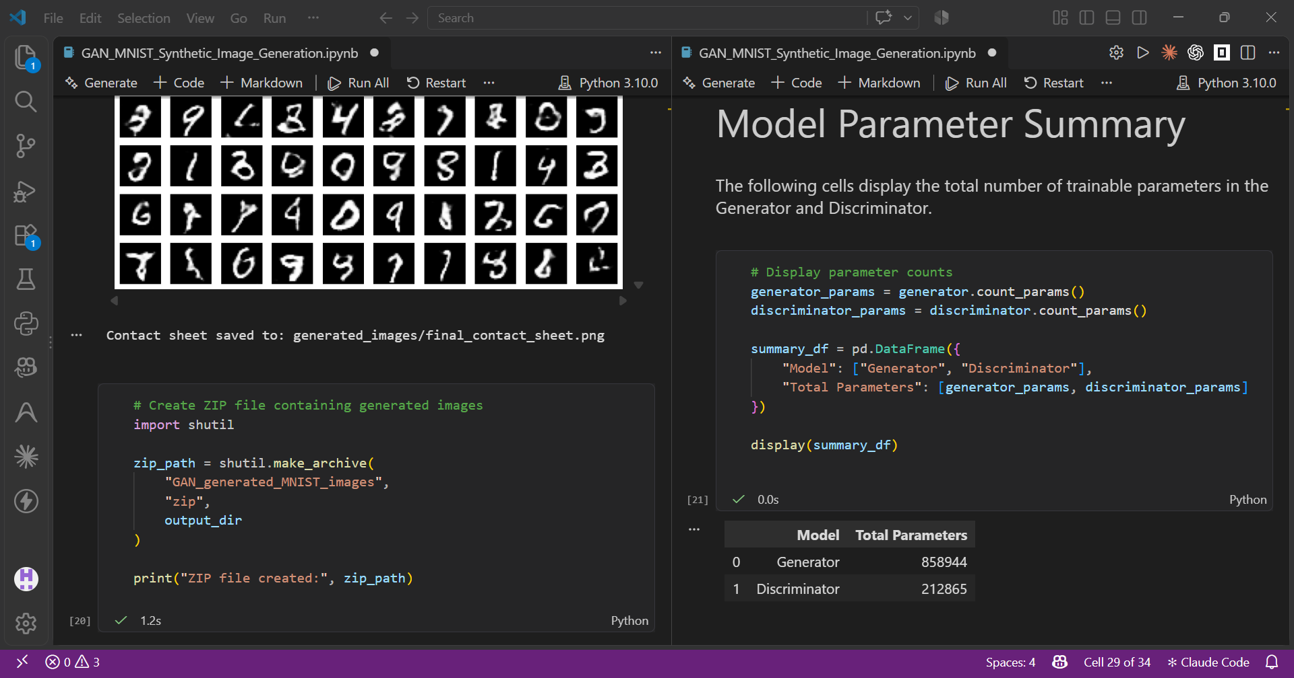

GitHub: https://github.com/Pradeep-Manikandan-1-D/24BAD088_DEEP_LEARNING_LAB
ASSESSMENT
Description | Max Marks | Marks Awarded
Pre Lab Exercise | 5
In Lab Exercise | 10
Post Lab Exercise | 5
Viva | 10
Total | 30
Faculty Signature

